›Valley Center Hornet Marching Band in the KBA Marching Championships @ Emporia State University Emporia, KS. Oct 18th, 2025

We will load the majority of equipment after the Senior Game Performance Friday Oct 17th. Take your uniforms & instruments home after the game.

Uniform: FULL UNIFORM Uniform Shirt, Jacket, Bibbers, Shako, Gauntlets, Gloves, 2025 SHOW SHIRT, Marching Shoes, Black Mid-Calf BLACK Socks , Wristbands, IN UNIFORM GARMENT BAG & DUFFLE BAG. Guard-Costume and Makeup.

Schedule:
5:15am Report to VCHS – Load Truck, Van & Trailer Busses and Trailers. Come dressed in Bibbers/Uniform Shirt/Marching Shoes w/Black Socks.

5:30am Depart VCHS for Emporia, KS
Emporia State University Welch Stadium
1600 Morse Dr Emporia, KS 66801

7:15am Arrive @ ESU. Immediately unload Busses/Trailers. Dress into Full Uniform. Will need parent help to begin unloading before students make it down.

Directions for Parking & Traffic:
- Exit 130 off of i35
- Drop off & unload on Wooster Drive in front of Wilson Park (Camp 6)
- Winds, Brass & Battery warm up in Wind Warm Up B (North of Camp 6)
- Pit Warm Up is between Health Physical Education & Recreation Building & Stadium
- Buses park at Emporia High School (separate location)
- Truck & Trailer park off Morse Drive in lot across from Wildlife & Parks Department
- Buses & trailer pick up on Wooster Drive (same location as drop off) following the band’s performance

8:00am To Warm-Up Area A
8:10am Physical/Music Warm-Up (30 min)
8:40am Band Exit Warm-Up (10 min)
Pit and Stage/Props to Staging
8:50am Report to Gate: Pre-Placement (10 min)

9:00am Valley Center Hornet Marching Band Performs

Back to buses after performance. Case up instruments. Grab Water. Load instruments & equipment back on trucks & trailer. Change into street clothes with show shirts.
10:45am Depart Emporia State for Roga Pumpkin Patch
(Have a sack lunch !!)

11am Roga Pumpkin Patch
150 Rd 140, Emporia, KS
11am-12:30pm
Admission-Free/Corn Maze $2.00/Hay Ride $2.00
Must have Sack Lunch/Limited Concession Available

12:20pm Depart back to Emporia State

1:15pm Back in Stands. Watch rest of Prelims

3:15pm Blue Valley Southwest (Last Ensemble of Prelims)

3:30pm Emporia State Performs

3:45pm Prelim Awards & Finalist Announcement

4:15pm Dinner provided by the Band-Aide. Students will dress back into uniform & prepare for Finals performance if we make it. (If we do not have a Finals Performance we will leave right after dinner.)

6:30pm Finals Begin. Top 12 Finals will begin at 6:30pm. Performance time based on draw. Load right after a potential Finals Performance.

9:30pm Finals Awards

10:00-10:15pm Restrooms/back to buses/head back to Valley. REMIND Text will be put out when we depart Emporia.

11:45-12:15am Approximate Arrival back at VCHS. Unload Uniforms & Instruments.
No trash left on buses or band room. Section Leaders & Drum Majors will check.

Parents please do not park in front of the back driveways to allow the trucks/trailer, and buses to unload.

HAVE RIDES WAITING AFTER UNLOADING !!

Admission: Adults - $10 Children (6-10): $5
2025 KBA Prelim Performance Schedule:
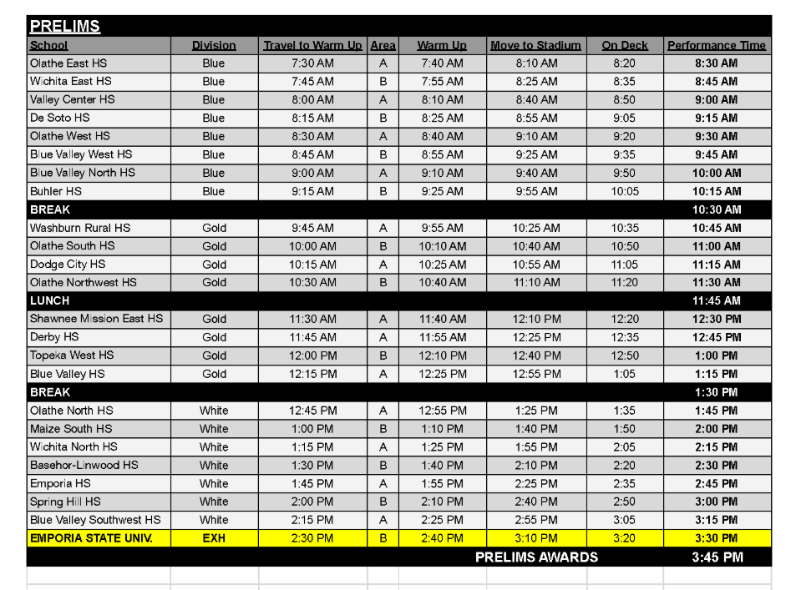
2025 KBA Finals Schedule:
